10 Linux Commands
1.
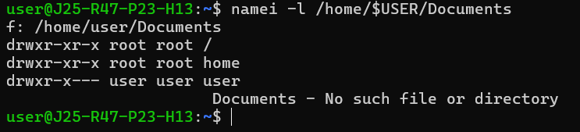
2.
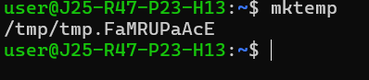
3.
4.
5.

6.
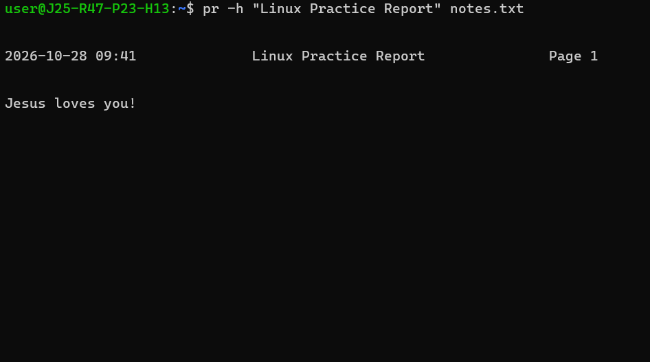
7.
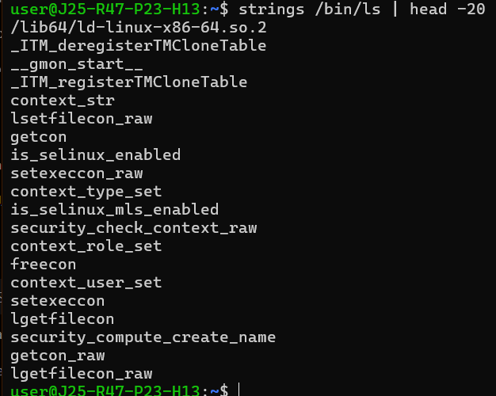

8.

Requests that pending filesystem changes be written to storage. Normally, Linux handles this automatically.
9.
Writes a message to the log file
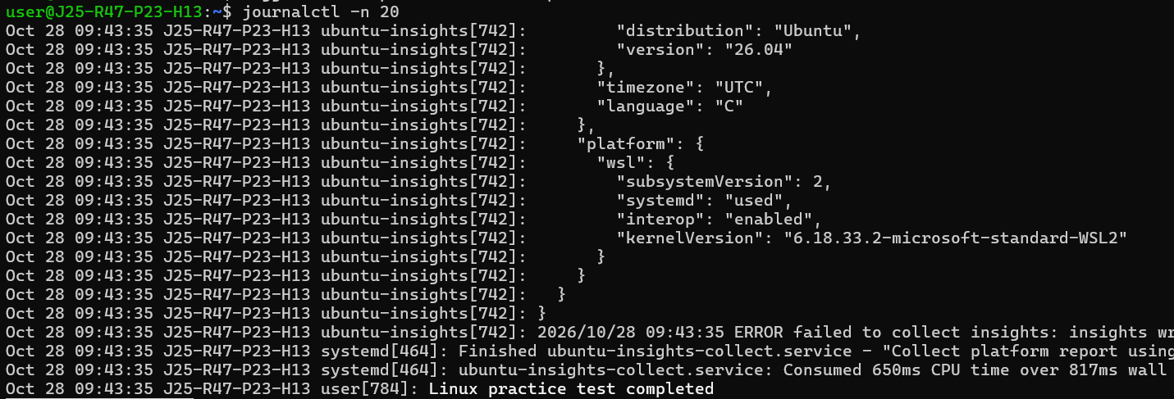
10.
